Module 1
Question and answer 1:
https://www.hackerearth.com/practice/basic-programming/input-output/basics-of-input-output/practice-problems/algorithm/io-exercise/
#include <stdio.h>
int main()
{
int N;
char S[16];

scanf("%d", &N);
scanf("%15s", S);

printf("%d\n", N * 2);
printf("%s\n", S);

return 0;
}
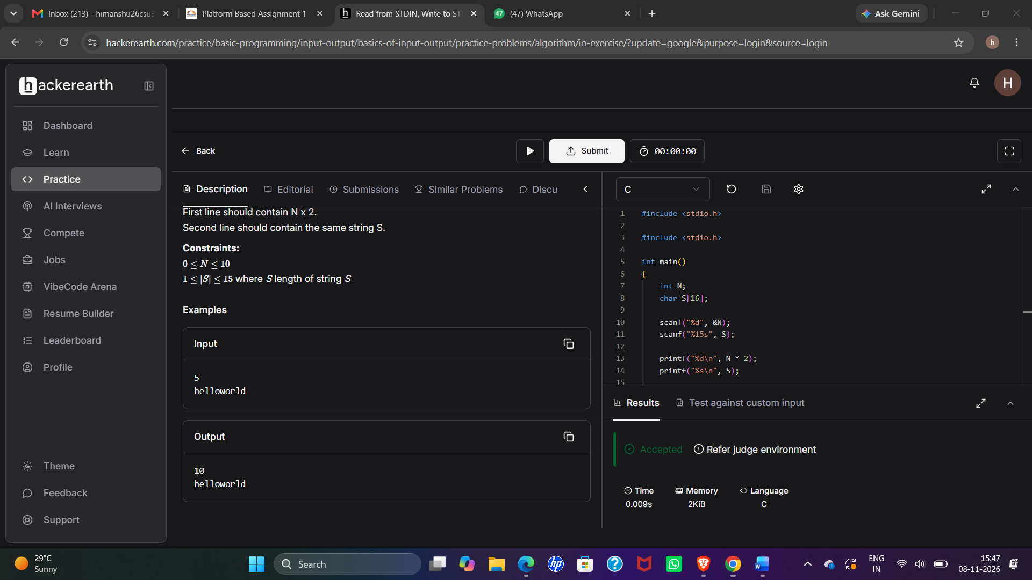

Module 1
Question and answer 2:
https://www.hackerrank.com/challenges/solve-me-first/problem
#include <stdio.h>

int solveMeFirst(int a, int b) {
return a + b;
}

int main() {
int a, b;
scanf("%d %d", &a, &b);

int sum = solveMeFirst(a, b);

printf("%d\n", sum);

return 0;
}

Module 1
Question and answer 3:
https://leetcode.com/problems/add-two-integers/submissions/2191869414/
#include <stdio.h>

int solveMeFirst(int a, int b) {
return a + b;
}

int main() {
int a, b;
scanf("%d %d", &a, &b);

int sum = solveMeFirst(a, b);

printf("%d\n", sum);

return 0;
}
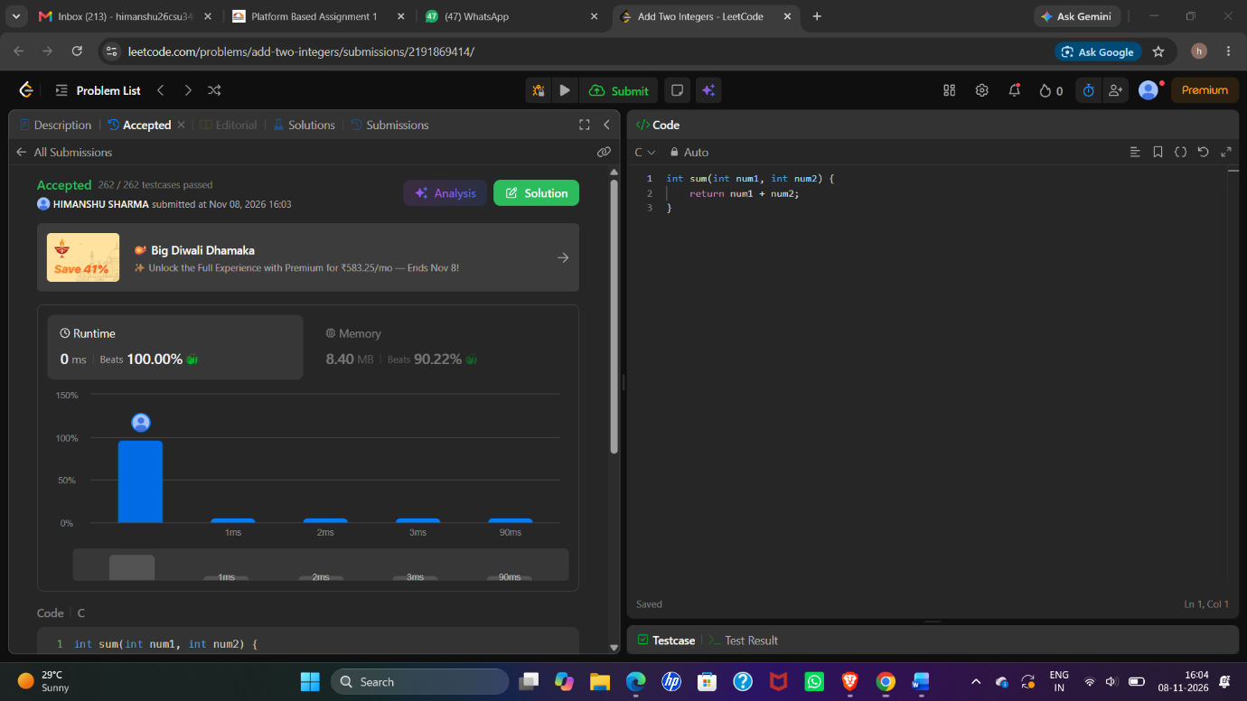
Module 1
Question and answer 4:
https://leetcode.com/problems/calculate-delayed-arrival-time/description/
int findDelayedArrivalTime(int arrivalTime, int delayedTime) {
return (arrivalTime + delayedTime) % 24;
}
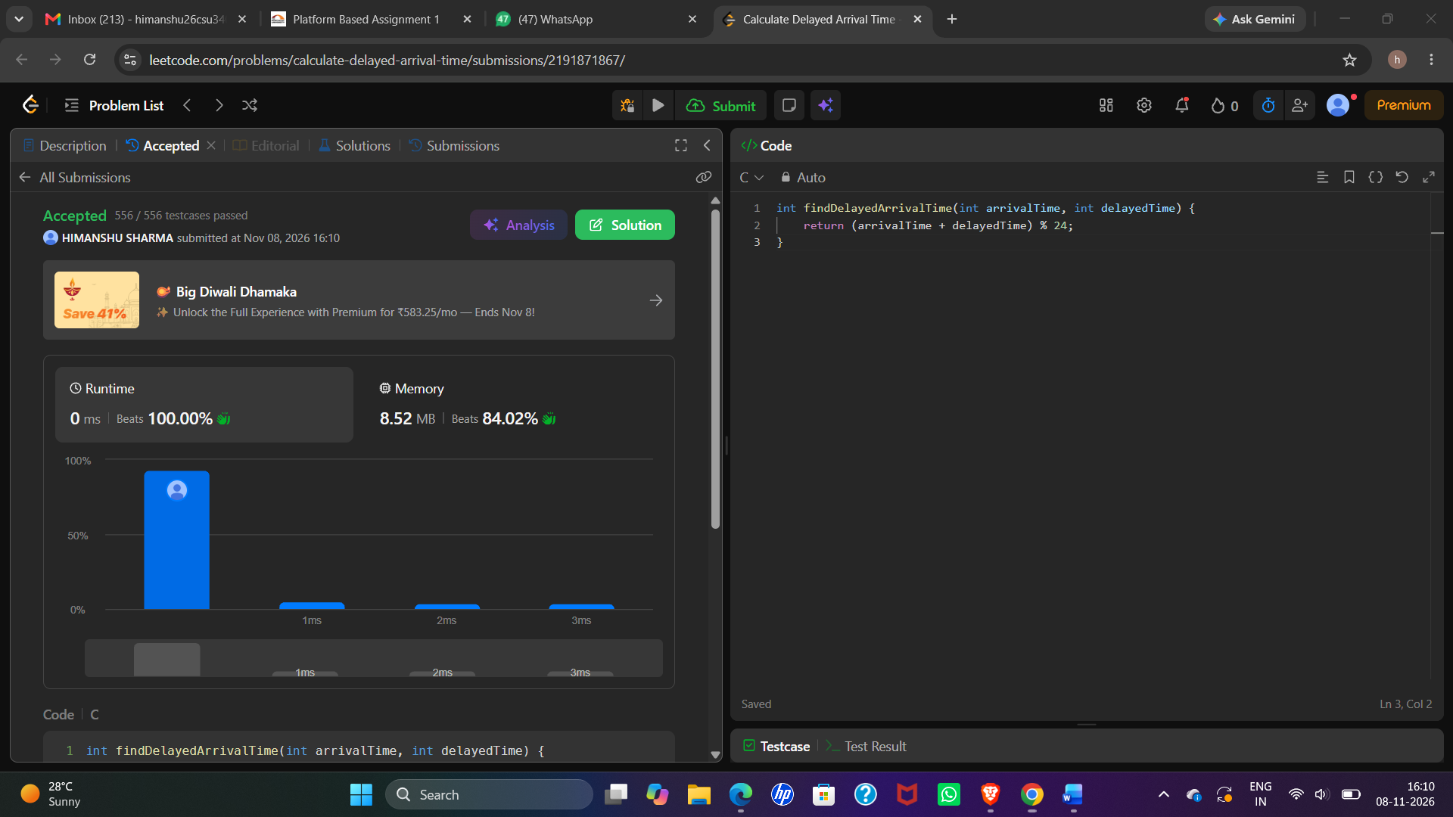

Module 1
Question and answer 5:
https://leetcode.com/problems/total-distance-traveled/description/
int distanceTraveled(int mainTank, int additionalTank) {
int distance = 0;

while (mainTank >= 5) {
distance += 50;
mainTank -= 5;

if (additionalTank > 0) {
mainTank += 1;
additionalTank -= 1;
}
}

distance += mainTank * 10;

return distance;
}

